Exercise 4.

Draw a UML diagram for ATM System using CASE tool. The banking system allows

a customer to access the financial transactions by ATM System, it has a step-by-step

process describe the work of this process and elaborate the what are the work can do by customer, banking system, administrator and technicians with the ATM system.

Aim:

To design a UML diagram for an ATM System that models the interactions between customers, the banking system, administrators, and technicians while performing financial transactions.

Procedure:

Identify the key actors:

Customer: Performs transactions like withdrawing, depositing, or checking balance.

Banking System: Processes transactions and maintains customer accounts.

Administrator: Manages the ATM system’s operational aspects, such as user permissions and logs.

Technician: Responsible for hardware and software maintenance of ATMs.

Define use cases for each actor:

Customer

Insert Card

Enter PIN

Withdraw Cash

Deposit Cash

Check Balance

Transfer Funds

Print Mini Statement

Banking System

Validate User

Process Transactions

Update Account

Notify Customer

Administrator

Monitor ATM Performance

Manage User Access

Technician

Perform ATM Maintenance

Repair ATM

Draw UML Diagrams:

Use Case Diagram (Shows interactions of actors with ATM system).

Class Diagram (Defines objects like Account, ATM, Customer).

Sequence Diagram (Represents the step-by-step interaction of a customer using an ATM).

Activity Diagram (Illustrates the process of an ATM transaction)

OUTPUT:

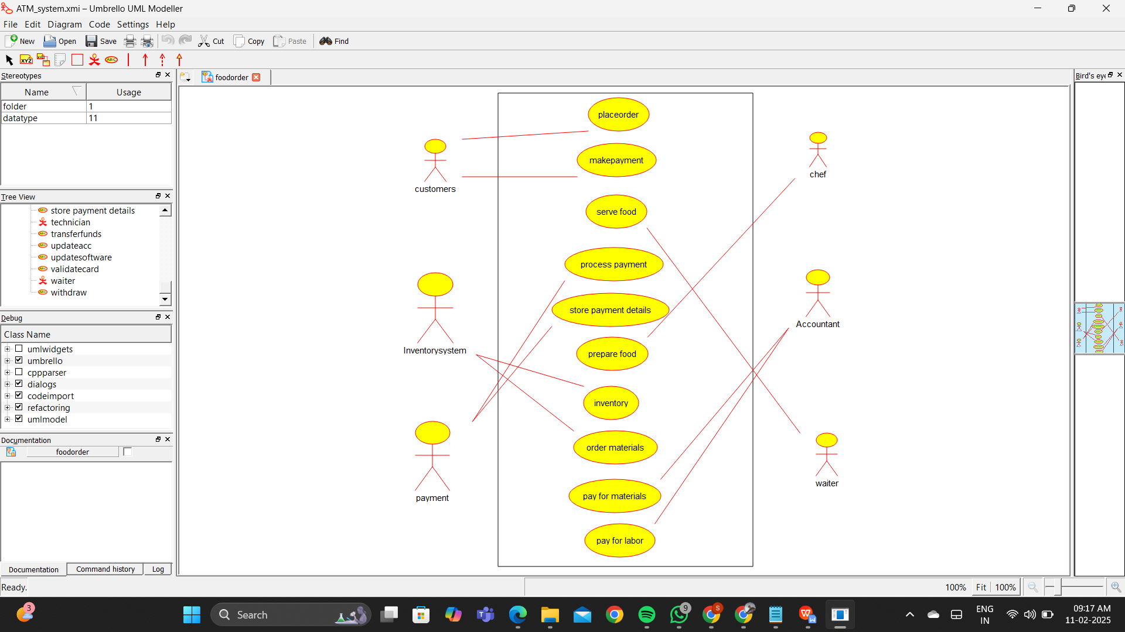

Result :

Thus the UML diagram has been implemented successfully.